

ACCESSIBLE ENTRANCES TO THE CATHEDRAL
East entrance
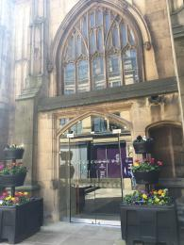
The East entrance to the Cathedral is accessible from pavement level. There are automatic glazed doors.

South entrance
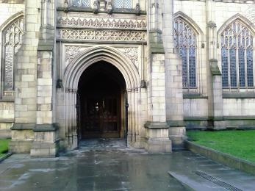
The South entrance has permanent sloped ramp, alongside steps to the entrance. The door is manual.

Both of the above entrances will give access to the Cathedral Nave, Fraser Chapel and sections of the Quire.

ACCESS WITHIN THE CATHEDRAL
Within the Cathedral building there are a handful of steps to each of the following.

Regimental Chapel
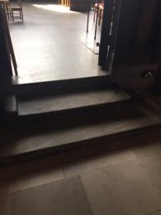
Access to the Regimental Chapel is via three small steps as shown above. There is no ramp.

Chapter House
Access to the Chapter House is via 4 steps as shown above. There is no lift and no ramp.
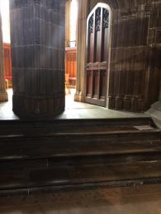

Lady Chapel
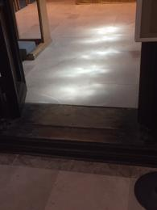
There is one wooden step into the Lady Chapel. There is no ramp and no lift.

Jesus Chapel
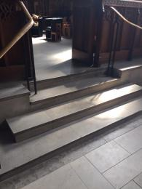
There are two access points to the Jesus Chapel - one has 3 steps and the other has 4 steps with handrails. There is no lift and no ramp.

Fraser Chapel
From the main entrance to this area, there is level access. The route is 1100mm wide, or more.
The door is 1100mm wide.
This chapel is also designated as a quiet space within the Cathedral and is glazed to help reduce background noise.

Quire
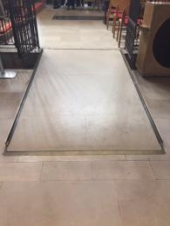
From the main entrance to this area, there is level access. There is a permanent ramp. The route is 1500mm wide.
There is limited accessibility within the Quire area with two steps from the High Altar area leading down to the Quire stalls.

HEARING
We have a hearing loop in the nave of the Cathedral.

VISUAL
Glass doors have contrast markings.

QUIET SPACES
We have designated the Fraser Chapel as a quiet space.

STAFF
Volunteer Welcomers are typically available to assist with access, and Cathedral Vergers are able to provide assistance upon request.
To contact us ahead of your visit with any questions or requests, please call the Cathedral office on 0161 833 2220.

